**Leader Overview**

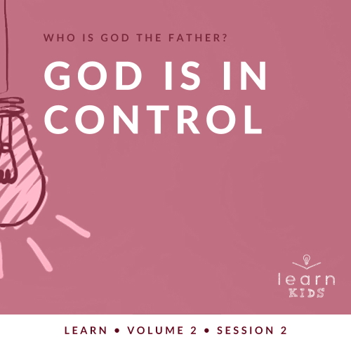

**Who is God the Father?**

*God the Father chose to reveal who He is throughout His Word. A robust picture of God can be seen by looking at His interactions with men and women like us. Since people first sinned in* [*Genesis 3*](https://ref.ly/logosref/Bible.Ge3)*, every generation has had to connect with our invisible God for themselves. Through these sessions about God, you have the opportunity to pass on this life-changing relationship to kids*.

**God Is in Control**

*Throughout the Old Testament, we see God establish His position in relation to His people. He is our Creator and Lord; therefore, we should desire for Him to be in control of our life. In our Bible story, we see God compared to a potter who molds clay. The potter works with the clay and molds it into what he desires it to be. In the same way, God has a plan and purpose for our life, too. He desires to mold us and help us grow into the people He has planned for us to be*.

**Bible Lesson**

God Is the Potter

[Jeremiah 18:1–11](https://ref.ly/logosref/Bible.Je18.1-11)

**Faith Fact**

My God is in control.

**Faith Verse**

[Isaiah 55:8](https://ref.ly/logosref/Bible.Is55.8) (NLT)

“My thoughts are nothing like your thoughts,” says the Lord. “And my ways are far beyond anything you could imagine.”

**Preparing for the Session**

**Leader Preparation Time: 20–25 Minutes**

|  |
| --- |
| ***You Will Need***  ***Large Group***   * *Bible* * *Worship songs (Song suggestions: “Your Love Awakens Me” by Phil Wickham; “Goodness of God” by Bethel Music; “Move” by Jesus Culture; “Faithful Now” by Vertical Worship)* * *For groups not using a phone or tablet only, add:*   *• Projector or TV*  *• Laptop*  *•* ***Faith Fact Slide***  *•* ***Faith Verse Video*** *or* ***Slide***  *•* ***Bible Lesson Video***  *•* ***Teaching Point Slides 1–3***  *• Smartphone with mapping app*  *• Modeling clay or play dough*  *• Piece of pottery*  ***Small Group***   * *Bibles for kids in your group to share* * ***Small Group Faith Verse Review****, one set per team* * *Scissors* * ***Small Group Activity Page****, one per kid* * *Pencils or pens, one per kid*   *To access session content from a computer, visit:*  [*BibleEngagementProject.com/downloads*](https://bibleengagementproject.com/Downloads) |
| ***Getting Ready***  ***Large Group***   * *Download videos and slides if needed.* * *Select worship song(s) and have them ready to play.* * *Read the Bible Lesson Scripture to prepare for teaching time.*   ***Small Group***   * *Print and cut apart the slips of the* ***Small Group Faith Verse Review****, one set per team.* * *Print copies of the* ***Small Group Activity Page****, one per kid.*   *First time leading* Learn *for Kids? Check out the* [*Facilitator Guide*](https://0b769b0ed3569ef9d18b-f88d8272f61086866d50d048b43ef630.ssl.cf2.rackcdn.com/sites/biblengagementproject/Listen_Facilitator_Guide.pdf)*.* |

**Large Group**

**30 Minutes**

*See what’s needed at the beginning of the session.*

**Introduction**

It’s great to see you all! If you were here last time, raise your hand. *(Group response)* Last time, we began to answer this very important question: Who is God the Father? We’ve already learned that God is the one true God. That means that all other gods or idols are just fakes or things that distract us from putting God first.

**Faith Fact**

Today, we’ll focus on the powerful fact that God is in control. In fact, today’s Faith Fact is **My God is in control**.

• *Show the* ***Faith Fact Slide***.

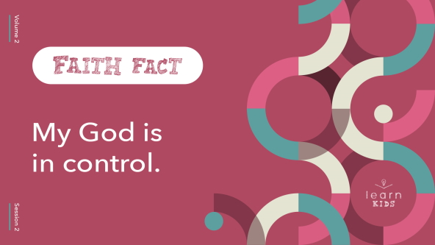

Let’s say it together. First, show me your muscles. Now, say it in your strongest voice. **My God is in control**. Let’s say it one more time. **My God is in control**. Great job!

**Game**

**Simon Says**

Today, we’ll learn that God is in control, but it’s not always easy to choose to follow Him. Let’s play a game to practice that. I think the game will be familiar to you—Simon Says. Let’s try it. Simon says, “Stand up.” *(Group response)* Simon says, “Touch your nose.” *(Group response)* Good job!

Now, when the leader doesn’t begin with “Simon Says,” you won’t do the action. For example, if I say, “Now sit down.” *(Group response)* Did Simon say to sit down? *(Group response)* Then, you should have just stayed standing up. Does everyone understand how to play now? *(Group response)* Let’s play!

• *Give kids directions that are easy to follow. Alternate between “Simon says” directions and simple directions*.

• *Kids should not be removed from the game if they make a mistake. The object is to help kids listen to directions and do them*.

• *Lead kids in actions like these:*

• *Jump*

• *Clap your hands three times*

• *Pat your head*

• *High-five your neighbor*

• *Say the Faith Fact*

• *If time allows, let kids take turns being the leader*.

In our game, we were supposed to do only the actions that Simon told us to do. Simon was in control. Sometimes it’s hard to allow someone else to lead us, but there is no one better than God to do that. When we live out our Faith Fact, God will be in control. Let’s say the Faith Fact now. **My God is in control**.

**Worship**

God instructs us in the Bible to do many things. One of those things is to worship Him. Let’s follow His instructions and worship Him together by singing.

• *Lead the kids in singing one or two praise songs. See suggestions at the beginning of the session*.

**Bible Lesson**

|  |
| --- |
| ***You Will Need***   * *Bible* * *Smartphone with mapping app* * *Modeling clay or play dough* * *Piece of pottery*   *No prep needed for this activity.* |

I always enjoy our time in worship, but I also love what’s up next. Can anyone guess what it is? *(Allow responses.)* We’re going to open God’s Word and learn something new from it today about God the Father. Let’s pray before we do that.

**Prayer**

|  |
| --- |
| *Dear God, thank You for Your control in my life and in this world. Help me to be willing to give my life fully over to You every day. Amen.* |

**Video Intro**

Before we listen to the Bible story, let’s watch this video.

• *Play* ***Bible Lesson Video***.

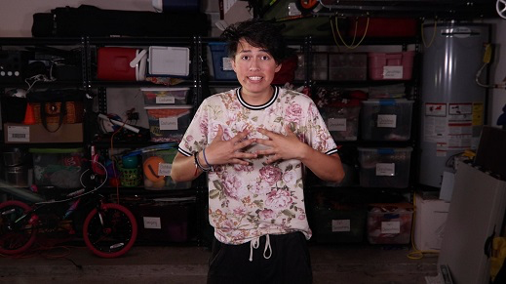

**Bible Story**

**God Is the Potter**

That’s such a fun lead-in to our Bible story! We’re going to learn about a message that God gave to one of the prophets in the Old Testament. Prophets shared what God told them with God’s special people, the Israelites.

If you want to follow along with our Bible story, open your Bible to [Jeremiah 18:1–11](https://ref.ly/logosref/Bible.Je18.1-11).

• *Read the Bible story aloud to the group*.

• *In order to keep Large Group time moving along, we don’t recommend having the kids read*.

• *Optional: Remind the kids to mark this place with their Bible Bookmark, so they can read it on their own at home*.

**Teaching Time**

This story from the Book of Jeremiah isn’t familiar to a lot of people. Raise your hand if that was the first time you had ever heard of God being like a potter. *(Group response)* It’s an incredibly powerful lesson that we can all learn from. God has the power to be completely in control of everything, including us.

**1. God is in control**.

• *Show the* ***Teaching Point 1 Slide***.

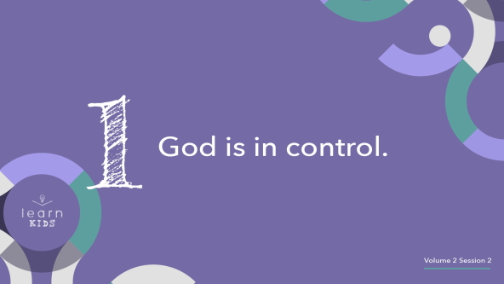

When people hear that God is in control, they often react in one of two ways. People either feel encouraged and excited or they feel scared because they aren’t in charge. It all depends on how you look at it. As Christians, we can trust that God being in control is a good thing. We should want to give control of our life over to Him, but others may not feel that way.

The Israelites struggled with allowing God to be in control. They actually said to the prophet Jeremiah, “Don’t waste your breath. We’ll continue to live as we want to, stubbornly following our own evil desires” ([Jeremiah 18:12](https://ref.ly/logosref/Bible.Je18.12)). Sometimes people want to live their life the way they want rather than how God wants them to.

They think God being in control is like He’s a puppet master up in heaven. He’s pulling all the strings, making us do what He wants. Let me show you what I mean.

• *Bring two volunteers to the front*.

One of the volunteers is going to be the puppet. That means they can’t move without the help of the other volunteer. The other volunteer is going to be the puppet master who is responsible for moving the puppet.

• *Choose which roles the volunteers will play*.

Okay volunteers, are you ready? Move the puppet so they are waving their hand. *(Pause for them to respond.)* Now, make the puppet pretend to kick a ball. *(Pause for them to respond.)* Lastly, make the puppet look happy. *(Pause for them to respond.)*

Some people think of a controlling God who makes us do everything whether we like it or not. God absolutely has the power to “pull our strings” or make us do what He wants, but He chooses to let us decide if He is in control. He gave us something called free will. That means we get to choose what we do with our life. We can choose to give Him control or not. However, our choices have both good and bad consequences.

**2. God has plans for His people**.

• *Show the* ***Teaching Point 2 Slide***.

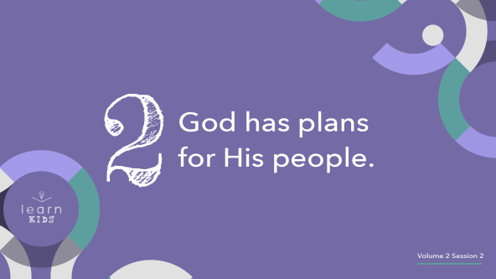

Thankfully, God has a plan for each one of us. He isn’t going to force us to follow it though. He didn’t force the Israelites to follow His plan, and they made lots of mistakes along the way. They rebelled against God and followed their own plan many times. How do you think that worked out for them? *(Allow responses.)*

It’s like when you’re going somewhere you’ve never been before. You have a mapping app on your phone that tells you exactly how to get there. In fact, the mapping app has the best and fastest route to get you exactly where you need to go. All you have to do is follow the directions.

• *Hold up a phone or device with a mapping app on it*.

• *Consider talking to your phone and asking it for directions*.

Choosing to follow your own plans instead of God’s plans is like putting your phone in your pocket and trying to find your way to the new location all by yourself. Maybe you would eventually get there, but you might get lost along the way. It would definitely take you much longer to get there. You might not even make it to the destination at all. When you choose to let God be in control, you can be sure that God’s plans will always be the best plans for your life.

**3. We can trust God to mold us**.

* *Show the* ***Teaching Point 3 Slide***.

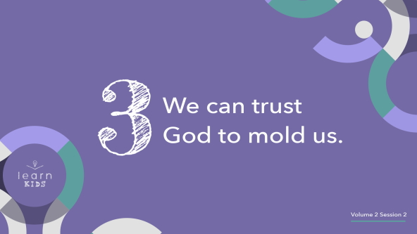

God is the Creator of the universe. He is the ultimate potter. We’re His creation and His clay to mold.

• *Pull out the modeling clay or play dough and mold it with your hands while you talk*.

That might sound a little scary to us when we think about it. What if God takes things away from me that I want to keep?

• *Pull off a couple of pieces of the modeling clay or play dough and drop it on the floor*.

What if He crushes my dream and keeps me from doing what I want to do?

• *Smash the modeling clay or play dough in your hands*.

We must trust God and give Him control over our life to mold us. If things get taken away and dreams don’t happen, we need to trust that God has something better for us. He always does.

• *Begin to shape the modeling clay or play dough into something nice*.

When we trust God to be in control of our life, He will shape us into something beautiful. He will use us to do amazing things for Him.

• *Reveal a piece of beautiful pottery*.

In fact, this beautiful creation shows that amazing things can come from a ball of clay. It’s the same with our life. God can do amazing things with us if we’ll give Him control and let Him mold us.

**Prayer and Response**

*Consider playing a worship song softly in the background while kids pray*.

Will you be like clay and allow God to mold you? Will you let Him guide you or will you respond like the Israelites and go with your own plan instead? It’s your choice because God allows you to choose. Remember, God’s plans will always be the best even if they are painful or we don’t always agree with them.

If you’re willing to give God complete control of your life, raise your hands in the air and tell Him that right now. *(Pause while kids respond.)*

If you raised your hands in the air, I want you to take another bold step forward. I want you to come to the front of the room.

• *Give a small piece of modeling clay or play dough to each of the kids*.

I want you take this clay in your hand. Just mold it for a second. As you mold this small piece, I want you to think about how God wants to mold you. Right now, you’re still young, but you can do incredible things for Him. You just need to let Him be in control of your life. Let’s pray.

**Prayer**

• *Optional: Have the kids repeat phrases of the prayer after you*.

|  |
| --- |
| Dear God, we want You to mold us. We’re asking You to mold us. We want You to be in control of our life. Guide us, direct us, grow us, challenge us, and use us for Your purpose. Amen. |

**Faith Verse**

Our Faith Verse is just one of many ways the Bible shows us why it makes sense for God to be in control. He knows so much more than we could ever know about what’s best. Let’s review it together.

• *Play* ***Faith Verse Video***.

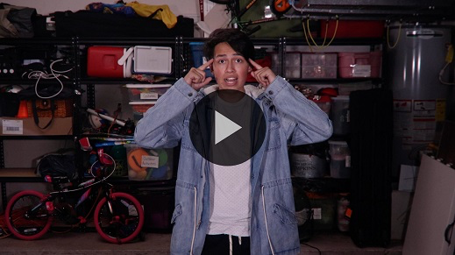

[Isaiah 55:8](https://ref.ly/logosref/Bible.Is55.8) (NLT)

“My thoughts are nothing like your thoughts,” says the Lord. “And my ways are far beyond anything you could imagine.”

**Faith Fact**

When we trust God to be in control of our life, we can be sure that His way is the best way. It’s such a relief to know that we don’t have to figure it all out on our own. Before we go to our small groups, let’s review our Faith Fact again.

• *Show the* ***Faith Fact Slide***.



Say it with me. **My God is in control**. It’s a daily choice to allow God to be in control and follow His plan. I hope that you’ll make that choice every day.

• *Dismiss kids to Small Group time or to go home if your group time ends here*.

**Small Group**

**30 Minutes**

*This section can be done in conjunction with the large group or on its own if you do small groups with your kids. During Small Group time, the goal is to connect the kids with the Word of God and to each other. All activities are led by the small group leader.*

**Group Connection**

**Stop, Go, Slow!**

God is in control of His creation. If He decides to do something, nothing has the power to stop Him. In our game today, you’re going to stand across the room from the leader. Your goal is to get as close to the leader as you can. However, the leader will be in full control over your actions.

If the leader says, “Stop,” you must stop. If the leader says, “Go,” you can continue moving. If the leader says, “Slow,” you must move very slowly. Whatever instructions the leader gives, you must follow. If you choose not to follow the instructions, you’ll have to go back to the starting place. The first person to reach the leader by following the instructions wins.

• *Have kids line up on one side of the room*.

• *Choose a kid to be the first leader and have them stand across the room from the group*.

• *Challenge: Add “go back” or “go forward” a certain number of steps and “freeze” to make it more interesting for older kids*.

• *Allow the winner to be the next leader and play again if you have time*.

**Learn about It**

|  |
| --- |
| ***You Will Need***  *• Bibles for kids in your group to share*  *No prep needed for this activity.* |

**Scripture Search:** [**Psalm 118:6–7**](https://ref.ly/logosref/Bible.Ps118.6-7)**;** [**Psalm 23**](https://ref.ly/logosref/Bible.Ps23)**;** [**Jeremiah 18:1–6**](https://ref.ly/logosref/Bible.Je18.1-6)

Let’s dig deeper into God’s Word and see what else He has to say to us. As we find and read each of these verses, let’s consider: What does this Scripture mean for our life today?

• *Give each kid a Bible and search for one or more of the Scriptures as a group together (as time allows). When everyone has found the Scripture, have one of the kids read it. Then answer the questions about it*.

• *Pair kids who need additional help with older kids or start simple and look up the session’s Bible story Scripture:* [*Jeremiah 18:1–11*](https://ref.ly/logosref/Bible.Je18.1-11)*. Kids will get better finding Scriptures the more they practice*.

• *Optional: Make this a competition to see who can find the Scripture first*.

**Bible Reading Tip**

Here’s a Bible tip for you. When you’re struggling to know if someone is telling you the truth about God, it’s good to think of different stories in the Bible and how God acted and treated people in them. The Bible is the best place to go to find out what is true and what is false about who God is.

**Challenge**

Every time you feel like you want to be in control this week, take a moment and say the Faith Fact to yourself. Maybe there will be times when you’re frustrated or tired, or things aren’t going your way. Stop what you’re doing, say the Faith Fact, and remember that God’s plan is best.

**Faith Fact**

Let’s shout our Faith Fact. **My God is in control**. Let’s say it one more time. **My God is in control**. Great job!

**Group Discussion**

*Feel free to use all or just a few questions as a jumping-off place for good discussion. Questions marked with * are designed for more conversation. Adjust the questions based on the age or maturity of your group. Typically, older kids will be able to dive a little deeper than younger ones*.

**Questions**

• *If small group activities are not immediately following large group time, you may want to read the Bible story passage before this discussion*.

Where did God tell Jeremiah to go?

What did the potter do when the jar he was making didn’t turn out the way he wanted it to?

Who did God say that He is like in our Bible story?

What did the clay represent in the Bible story?

* Why is it a good idea to trust God with our life?

* What is something you have a hard time trusting God with?

* What is something you can do to show God that you fully trust Him?

* Would you rather follow God’s plans or create your own plan? Why?

* How do you feel about letting God be in control of your life? Explain.

**Prayer Requests**

*Finish group discussion by sharing prayer requests and praise reports. Keep track of your small group’s prayer requests and review them each time you meet*.

**Prayer**

*Have kids pray for each other’s prayer requests*.

**Faith Verse Review**

|  |
| --- |
| ***You Will Need***   * ***Small Group Faith Verse Review****, one set per team* * *Scissors*   ***Getting Ready***   * *Print and cut apart the slips of the* ***Small Group Faith Verse Review****, one set per team.* |

Our Faith Verse is [Isaiah 55:8](https://ref.ly/logosref/Bible.Is55.8). It reminds us of why we should allow God to be in control. Let’s watch the Faith Verse video and do the actions for the verse together.

• *Show* ***Faith Verse Video***.



[Isaiah 55:8](https://ref.ly/logosref/Bible.Is55.8) (NLT)

“My thoughts are nothing like your thoughts,” says the Lord. “And my ways are far beyond anything you could imagine.”

Who thinks they know the verse already?

• *Let kids say the Faith Verse on their own*.

• *Choose two kids from the kids who quoted the verse to be the leaders in the game*.

**Faith Verse Fun**

**Verse Control**

I’ve chosen two of you who believe you know the Faith Verse to be the leaders. The leaders will be in control of their teams for this game. You can only follow your leader’s instructions. Leaders, you’ll have to give very specific instructions to help your team put the Faith Verse cards in the correct order. If they act on their own, your team will be disqualified. The first team to get their verse cards in the correct order wins.

• *Divide the group into two teams and appoint a leader of each team*.

• *Give each team the* ***Small Group Faith Verse Review*** *slips*.

Everyone ready? Leaders, start giving directions to your team.

• *Allow the teams to put the Faith Verse in order*.

Was it easy or difficult to follow the leader’s instructions? *(Group response)* Leaders, did your team listen to and follow all of your instructions? *(Allow responses.)* This is a lot like what God wants us to do. Making Him our Leader gives Him control. That’s why our Faith Fact is important to remember. Let’s say it together. **My God is in control**.

**Activity Page**

**Life’s a Maze!**

|  |
| --- |
| ***You Will Need***   * ***Small Group Activity Page****, one per kid* * *Pencils or pens, one per kid*   ***Getting Ready***   * *Print copies of the* ***Small Group Activity Page****, one per kid.* |

God is in control, but we have to allow Him to be a part of every decision we make. We can do that by reading the Bible and following what it teaches us. We can also pray and ask Him to guide us. Then, we need to follow His directions. His plan for our life is the best one.

• *Give each kid a copy of the* ***Small Group Activity Page*** *and a pencil*.

• *Let kids complete the maze*.

Take time to complete the maze and remember that following God’s plan for your life is the only way to get His reward.

**Dismissal**

Thanks for learning more about God with me today. It’s not always easy to let Him be in control, but it’s always best. Let’s close in prayer.

**Prayer**

|  |
| --- |
| *Dear God, thank You for molding us and allowing us to be used by You. Amen.* |

**Faith Fact Recap**

• *Show the* ***Faith Fact Slide***.



One important thing I want you to remember from today is our Faith Fact. Let’s say it together. **My God is in control**. I’m glad you came today. I can’t wait to see you next time.

• *Send home the* ***Small Group Activity Page***.

• *Remind parents that there are* ***Family Devotions*** *available on the app to do with their kid*.

• *Tell everyone the date and time for the next session*.